Hi

Please answer below question before we go further details

First of all, thank for interested in this Job, let me explain briefly so that you will get the idea on overall

<https://streamonline18.wixsite.com/online18>

above is the web that I created using Wix , this is just an example how I want the Single web look likes

- based on above, its on few pages, No worries, I believe you understand Single Web, any link just to the same page.

- But if you have the design similarly like above, you may propose.

1. I just need a single web + admin page

- Do you have done using any **Free** Template + admin page ? What would you using?

- If not, what is the **price range** if we want to develop Single web + admin page?

2. Regarding the Login for Website 🡪 here we need to design based on below

You can check on <https://streamonline18.wixsite.com/online18> --> go to login

* I need similar to this or any other similar login

3. Now, we come to the part that I want to control over.

Now – we move to When they do Log-in how the MENU will look like, for this I just give an idea, as I am not sure how it may look like in reality.

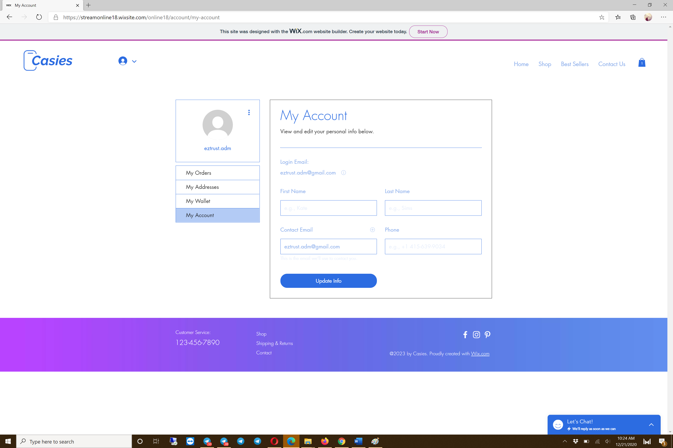

We need to change in Here

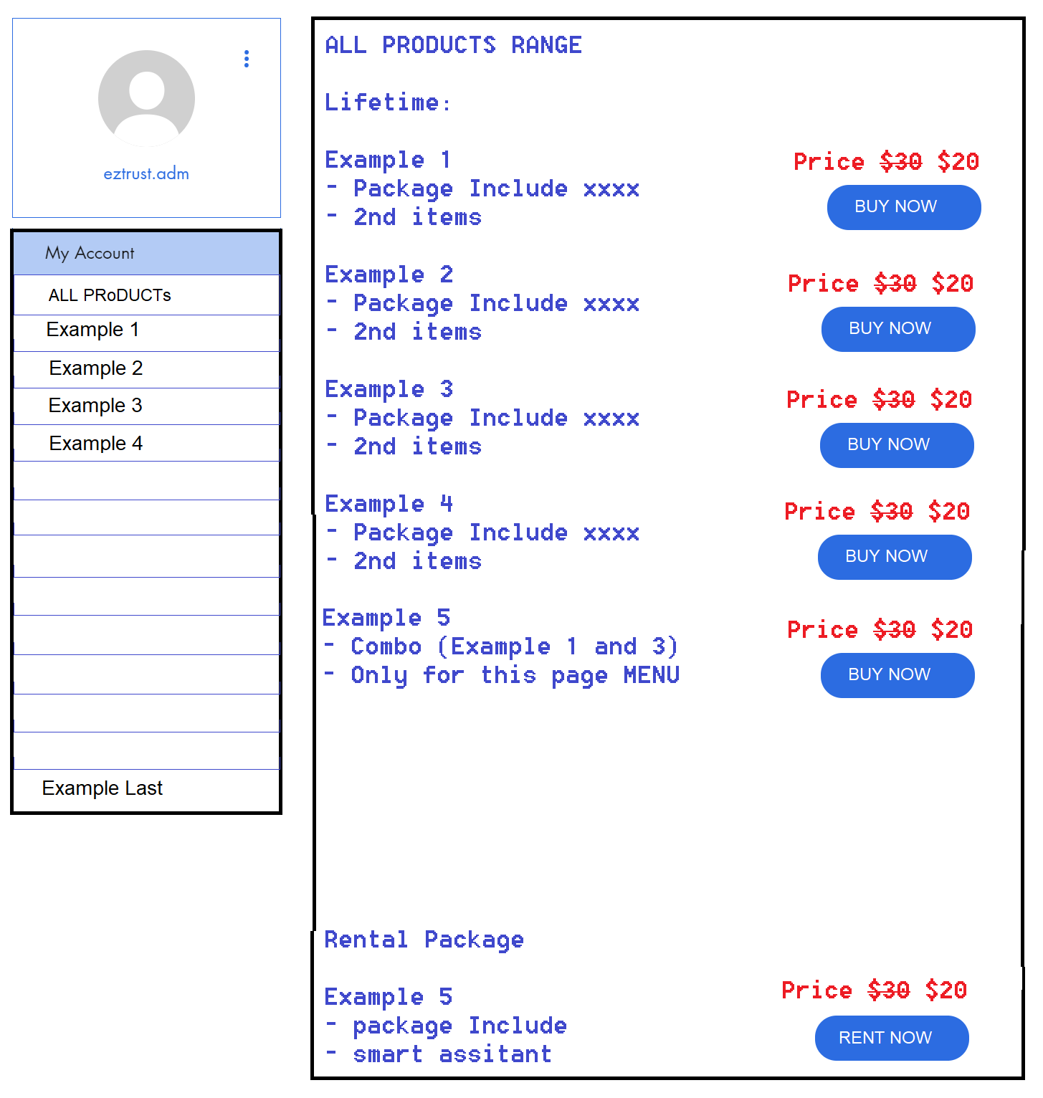

Now this is ON ALL Products MENU, This is just an example, later you may show how to add or remove

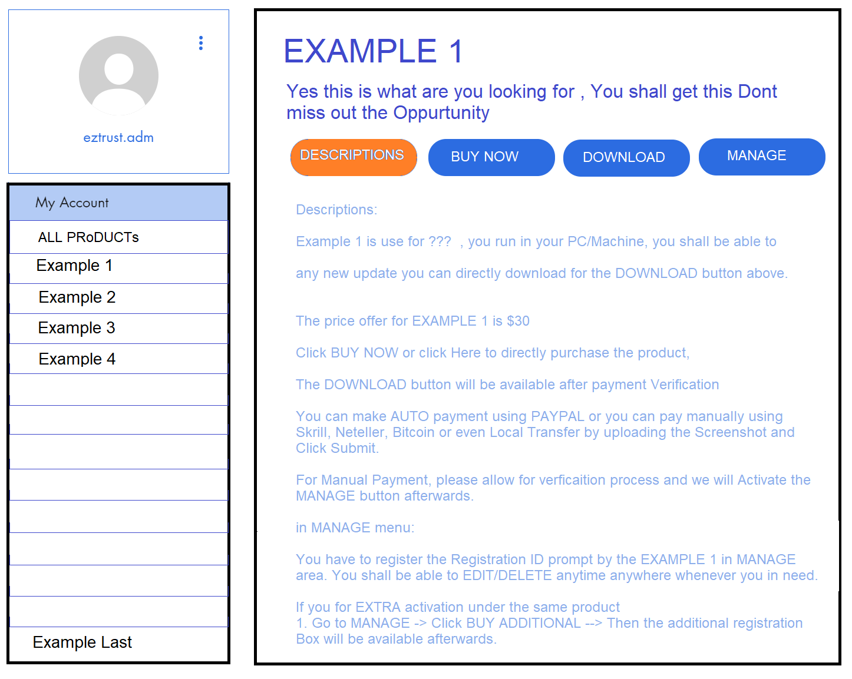

For Lifetime Products we divided into 4 Categories

DESCRIPTIONS - Here we will write about the products descriptions

BUY NOW - When they click BUY NOW, it will prompt payment METHOD as described previously

DOWNLOAD

* The DOWNLOAD button will ONLY available once, they make the payment or we verified the payment, Once this Product has been purchase, the BUY NOW button will not be available for click (to show that they already purchase the product (auto or manual)
* It will directly Download from the link (don’t have to make a menu for this)

MANAGE

* Only available if the payment Already verified / made. Here they can manage The Registration for the ID
* Check the Next Photo how, it may look like

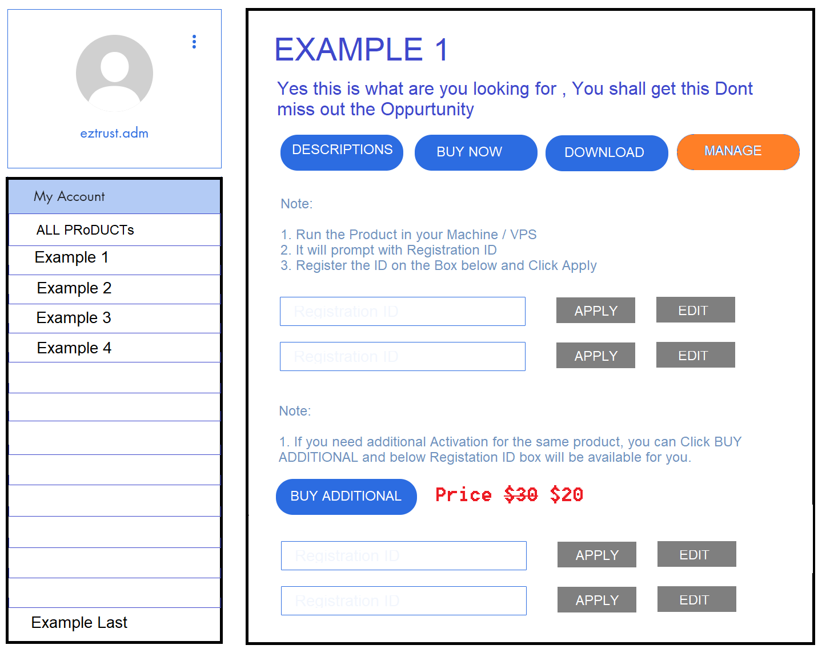

Once they made a payment, then the first 2 boxes will be available for them to APPLY/EDIT

This is the basic Idea (what im thinking to do it) – details discussion to be discuss once we agreed on all aspects.

Please answer below questions:

1. Do you able to do it the custom Web as above? YES or NO

2. What would you recommended using Free Template+admin or using Paid Template+ admin ?

3. For Custom After Log-in 🡪 Do you able to integrate it? What would you recommend, is it using Web Hosting or MySqL database? and Please explain why

4. What is your Final Price and Timelines to complete?

5. Any other good suggestion / recommendation?

6. Any other questions?